Level 3 – AS91583 – 4 Credits – Internal
Conduct an Experiment to Investigate a Situation
Written by J Wills – MathsNZ – jwills@mathsnz.com

Achievement | Achievement with Merit | Achievement with Excellence
Conduct an experiment to investigate a situation using experimental design principles. | Conduct an experiment to investigate a situation using experimental design principles, with justification. | Conduct an experiment to investigate a situation using experimental design principles, with statistical insight.

Contents:
Teacher Notes 2
More Experiment Ideas 2
Further clarification of requirements for Achieved, Merit, and Excellence 2
Vocabulary List 3
Experiment 1a: Walking Babies 4
Manual Re-randomisation Task 5
Using NZGrapher 7
Experiment 1b: Walking Babies (new data) 10
Experiment 2: Throwing Paper 12
Experiment 3: Dominant Hand 15
Experiment 4: Memory Test 18
Internal Checklist 18
Sample Internal (at Achieved level) 22
Assessment Guidelines – 91583 – Conducting an Experiment 24

Teacher Notes
This booklet is slightly different to my other booklets, as it steps through by experiment rather than by section, so you do a whole experiment before moving onto the next one.
During this internal it is a really good idea to discuss the ethics of the experiments that are being conducted, a lot of the data we have access to now that was produced in the past was not necessarily ethically produced, which links heavily into the values in the New Zealand Curriculum.
For more see: http://new.censusatschool.org.nz/2014/09/19/values-ethics-and-statistical-experiments/

More Experiment Ideas
Can people memorise words better if they draw / imagine words as pictures?
Does the size of a box affect the weight that people guess it is (even when holding it)?
Does having your eyes open help you to estimate measurements?
Does knowing the dimensions of a page help when drawing dots a particular distance apart?
Do people think a drink / food tastes better if they know the brand?
Does jumping from your dominant foot improve your jumping length?
Does drinking from a bottle / cup labelled expired change the perception of taste?
Do you jump further if there is a target line marked out for you?
Can you perform a task quicker / better if given some advice, or have time to practice?
Do you estimate differently when asked how much time you spend doing a task in a week or in a day?
Does wearing an eye patch affect your ability to: play darts, run an obstacle course, walk without spilling a full glass of water, thread string through a hole, etc?
Does the colour of a word affect your ability to read it out loud? (http://www.onlinestrooptest.com)
Is it more difficult to redraw a picture when you are not told you need to?
Do you perform better in a test if you are told about it the day before?

Further clarification of requirements for Achieved, Merit, and Excellence
Achieved | Merit | Excellence
Conduct an experiment to investigate a situation using experimental design principles involves showing evidence of using each component of the investigation process. | Conduct an experiment to investigate a situation using experimental design principles, with justification involves linking components of the process of investigating a situation by experiment to the context, explaining relevant considerations in the investigation process, and supporting findings with statements which refer to evidence gained from the experiment. | Conduct an experiment to investigate a situation using experimental design principles, with statistical insight involves integrating statistical and contextual knowledge throughout the investigation process, and may include reflecting about the process; discussing how possible sources of variation were dealt with during the design phase; considering other relevant variables.

Vocabulary List
Bias | Something that causes favouritism.
Blocking | Process of placing the units into groups (blocks) that are similar in nature.
Cause | This is usually the treatment.
Context | The real world story or facts behind an experiment.
Control group | The group who does not receive the treatment.
Effect | The outcome of applying a treatment, measured by the response variable.
Experiment | Process of planning, running, and looking at the results of a test.
Experimental Group | Group of experimental units.
Experimental Unit | Single person who is being tested upon in an experiment.
Experimenter | Person or group of people in charge of running an experiment.
Hypothesis | Predication, or expectation. Usually made before an experiment.
Independent variable | Usually takes only two values, placebo and treatment.
Median | The central or middle value of an ordered dataset
Paired Comparison | An experiment on a single experimental group, taking a before and after measurement.
Placebo | Simply put, a fake treatment.
Purpose | The thoroughly developed line of reasons for running an experiment.
Random Allocation | Process of randomly assigning experimental units to groups using, for example a deck of cards or flipping a coin.
Randomisation test | Process of testing if chance alone is influencing the results from an experiment.
Response variable | The measurement that is the main focus of an experiment.
Spread | The spread of the data around the median, measured by the interquartile range (IQR) or standard deviation.
Treatment | An applied change or influence that should result in a change in the response variable.
Treatment group | The group who receives the treatment
Variable | A measurement, or characteristic (e.g weight or gender).

Experiment 1a: Walking Babies
Teachers note: This is adapted from Phillip R. Zelazo, Nancy A. Zelazo & Sarah Kolb, ‘Walking’ in the Newborn, Science, Volume 176 (1972), pp 314-315 and Statistics from Data to Decision: Watkins, Scheaffer & Cobb pp 515

Background:
We want to know if a special exercise programme will lower walking age. All participants in the study were volunteers. 10 male infants were randomly assigned to either the exercise group or the control group. The ages (in months) when these infants first walked without support are shown below:
Treatment | Age (Months)
Exercise | 9 | 9.5 | 9.75 | 10 | 11
Control | 13.25 | 11.5 | 12 | 13.5 | 11.5

This gives a graph that looks like this:
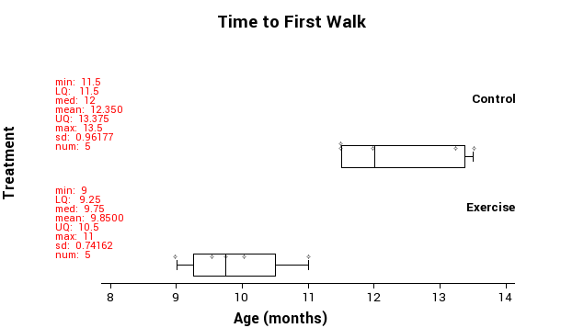

Does it appear that this data provides evidence that the exercise program is effective?

____________________________________________________________________________________________________________________________________________________________________________________________________________________________________________________________________________________________________________________________________________________________________________________________

Is it possible that these babies’ walking ages have nothing to do with whether they undertook the exercises or not? In other words did it matter what group the babies were in or would they have had the same walking age anyway? Is it possible that what we are seeing is just luck of the draw? There are two possible explanations.
- The data provides evidence to suggest there is a link between the exercises and walking age.
- The difference between the walking age could have been produced by chance alone.
The key phrase here is ‘chance alone’, in other words they just ended up this way by random chance.
To find out if it is actually making a difference we want to do a re-randomisation test. This is done by getting the data and randomly assigning it to one of the two groups. NZGrapher does this really quickly one thousand times, but for this time, we want to do it by hand to see what is happening.

Manual Re-randomisation Task
Cut out the cards below and use the axis on the next page to produce a dotplot of 30 differences between the medians (i.e. shuffle the cards into two groups, record the difference between the two medians, put a dot at the corresponding location on the dotplot. (Control - Exercise)

This activity can also be done online at: http://www.jake4maths.com/excon.php

Exercise | 9
Exercise | 9.5
Exercise | 9.75
Exercise | 10
Exercise | 11
Control | 13.25
Control | 11.5
Control | 12
Control | 13.5
Control | 11.5

Time to First Walk

Difference Between Medians

Using NZGrapher
Fortunately we don’t normally need to do this by hand, we can just do it using the computer.
There is a video version of this at students.mathsnz.com
Go to NZGrapher: www.jake4maths.com/grapher
And select the Data Source: “Empty Dataset for Editing” in the top right corner. You should now have a screen that looks like this:

For more information about NZGrapher please visit it online and see the ‘about’ and ‘graphs’ pages.
On the left hand side add in as many rows as you need (using the ‘Add Row’ button), and type the data in. Once you have finished typing it in press ‘Save Changes’.

We need two graphs. The first one is the dotplot. To get a dotplot, on the bottom left we need to select the numerical field as the x-variable and the group as the y-variable and then change the graph type to dotplot. This produces a dot plot with the box and whisker and summary statistics.

Don’t forget to give a good title and axis labels (over on the bottom right)
The last graph that we need is the bootstrap re-randomisation (either mean or median) which you can get by just changing the graph type

From this we can see the likelihood of getting a difference of 2.25 months or more between the medians by chance alone is just 0.035, which is not very likely.

The cut over point where it might be chance alone is 0.1
Let’s put it all together now into the format we need for the internal:
Babies Walking | Title is given
Problem
A researcher wants to know if _____________ helps babies ___________ sooner. | Reason given for investigation
Therefore I wonder if whether a ______________ doing the ____________ or not causes a difference in _________________ based on a sample of _____ babies who ________________________________________________________________________ | Causal relationship question posed
I predict __________________________________________________________________ | Prediction given
Plan
For the experiment we had ___ male babies who volunteered and were randomly assigned to either the __________ group or the ____________ group. The babies that were in the ____________ group performed a series of exercises daily and the age of the baby when it first walked was recorded in months. | Experiment is described including how groups chosen
The treatment variable is if the baby __________________________ or not, and the response variable is how old the baby is ________________________. | Identification of treatment and response variables
In order to reduce any variation due to other factors, all of the babies were ________ as different genders might affect it. Also, because all of the babies volunteered __________________________________________________________________________ | Other sources of variation
Experiment
During this section we would need to discuss any sources of variation that occurred during the experiment, but as we didn’t do the experiment we can’t do this. | Any issues that arose stated
Data
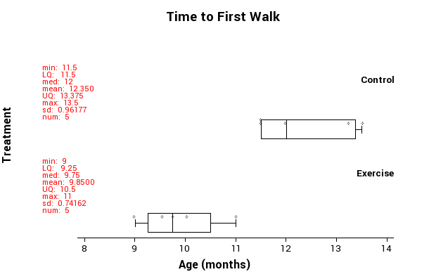 | Graph displayed with summary statistics
Analysis
All of the _____________ group took longer to walk than the ___________ group. The control group median was _________________ higher than the ________________ group and the control group mean was __________________ higher than the ________________ group. | Key features of the displays and statistics are described
I need to find out if a difference between the medians of 2.25 months is likely to just be from chance alone, or if this could be due to ________________________________  I used the randomisation test on the medians and the results are shown below. | Statement of what test is going to be carried out
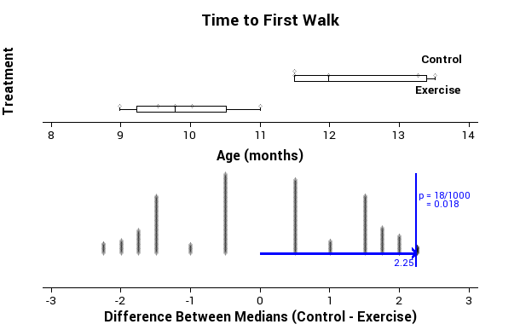 | Results of the test are displayed
A difference of 2.25 or more comes up 18 times of the 1000. | Summary given
As 1.8% of estimates produced by random allocation are at least as far from zero as the observed estimate, then the data provides evidence there may be a link between the two variables. This means that because the probability is low, it would be highly unlikely a difference of 2.25 months would happen by chance alone. | Inference stated
Conclusion
Overall I see that there is sufficient evidence to support the claim _____________ who do ____________________ are likely to walk before _____________________________ | Conclusion given
Appendix: Data
Estimates of ages:  Exercise: 9, 9.5, 9.75, 10, 11  Control: 13.25, 11.5, 12, 13.5, 11.5 | Raw data given as appendix.

Experiment 1b: Walking Babies (new data)
Now, this is one nice set of results, but what happens if the data was slightly different. Let’s look at the same experiment again, but do it from the data section with a slightly different set of data:
Original Data:
Treatment | Age (Months)
Exercise | 9 | 9.5 | 9.75 | 10 | 11
Control | 13.25 | 11.5 | 12 | 13.5 | 11.5

New Data:
Treatment | Age (Months)
Exercise | 9 | 9.5 | 9.75 | 10 | 12.5
Control | 10.25 | 11.5 | 12 | 13.5 | 11.5

Note: only two pieces of data have changed, the items in bold.

Problem, Plan and Experiment the same as before…

Data
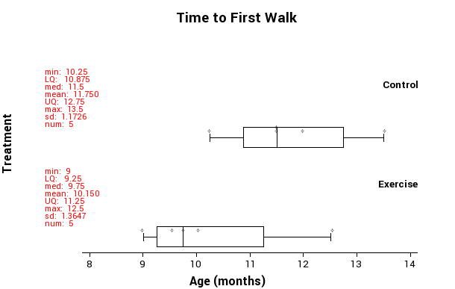 | Graph displayed with summary statistics

Analysis
On average the _____________ group took longer to walk than the ___________ group. The control group median was _________________ higher than the ________________ group and the control group mean was ___________________ higher than the ________________ group. | Key features of the displays and statistics are described
I need to find out if a difference between the medians of ________________________ is likely to just be from chance alone, or if this could be due to ____________________ ___________________________________________________________________________  I used the randomisation test on the medians and the results are shown below. | Statement of what test is going to be carried out
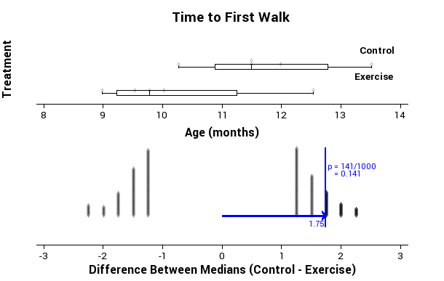 | Results of the test are displayed
A difference of ________________ or more comes up ___________ times of the 1000. | Summary given
As _______% of estimates produced by random allocation are at least as far from zero as the observed estimate, then the data provides no evidence there may be a link between the two variables. This means that because the probability is _________, it would be ________________ a difference of 1.75 months would happen by chance alone. | Inference stated
Conclusion
Overall I see that there is ____________ evidence to support the claim _____________ who do ____________________ are likely to walk before _________________________ | Conclusion given
Appendix: Data
Estimates of ages:  Exercise: 9, 9.5, 9.75, 10, 12.5  Control: 10.25, 11.5, 12, 13.5, 11.5 | Raw data given as appendix.

Experiment 2: Throwing Paper
Teachers note: this experiment requires you using actual data, if you are unable to complete this experiment you can use the following data based on throwing 8 balls:
3m: 2, 2, 3, 3, 3, 4, 4, 4, 5, 5, 5, 6
5m: 0, 0, 0, 0, 1, 1, 1, 1, 2, 3, 4

Teachers notes:
The equipment for this experiment is: 8 sheets of paper to screw into a ball and an A4 5-ream paper box.

Background:
For this experiment we are going to investigate if the distance the target is away affects the ability of a student to be able to throw balls of paper into a box.
Things you will need to consider:
- What box will you be throwing the paper into?
- Where will the box be located? Will it have a backboard? Will you stop it moving?
- How many balls will be thrown?
- How will you determine the experimental groups?
- What will you do if an experimental unit normally wears prescription glasses?
- How will you ensure all the experimental units are the same distance away?
- How will you allow the balls to be thrown?
- Are there any environmental factors (light, wind, noise) that might affect the experiment?

The process we will go through is designing the experiment, carrying out the experiment, and then collating and analysing the data.
Throwing Paper | Title is given
Problem
Throwing balls into a target is often considered to be more difficult if the target is further away, but is this actually the case? | Reason given for investigation
Therefore I wonder if whether a student is _________ away or _________ away causes a difference in the _____________ of _____________ that can be ________________ based on a sample of _____________________________________. | Causal relationship question posed
I predict ___________________________________________________________________ ___________________________________________________________________________ | Prediction given
Plan
For the experiment we have ____ students in the _____________ class who were assigned to either the ____________ group or the ______________ group by flipping a coin, head is the group ________________ and tails is the group __________________. | Experiment is described including how groups chosen
The treatment variable is if the student is __________________________, and the response variable is ______________________________________________________ ___________________________________________________________________________ | Identification of treatment and response variables

In order to reduce any variation due to other factors, ____________________________ ________________________________________________________________________________________________________________________________________________________________________________________________________________________________________________________________________________________________________________________________________________________________________________________________________________________________________________________________________________________________________________________________________________________________________________________________________________________ | Other sources of variation (see list on previous page if you need ideas)

You now can conduct the experiment, you can record the data here, but this is normally included as an appendix at the end of the report.
Group | Number of Balls in the Box
Control
(3m away)
Treatment group (5m away)

Experiment
During the experiment ______________________________________________________  ____________________________________________________________________________________________________________________________________________________________________________________________________________________________________________________________________________________________________________ | Any issues that arose stated
Data
This is where you put your dot plot and box and whisker with the summary statistics displayed. | Graph displayed with summary statistics
Analysis
On average the __________________ group got more balls into the box than the ________________ group. The ______________ group median was ________________ higher than the ________________ group and the ________________ group mean was ___________________ higher than the ________________ group. | Key features of the displays and statistics are described
I need to find out if a difference between the medians of ______________________ is likely to just be from chance alone, or if this could be due to ______________________ ___________________________________________________________________________  I used the randomisation test on the medians and the results are shown below. | Statement of what test is going to be carried out
This is where we display the graph of the boostrap re-randomisation. | Results of the test are displayed
A difference of ________________ or more comes up ___________ times of the 1000. | Summary given
As __________% of estimates produced by random allocation are at least as far from zero as the observed estimate, then the data provides ________________ there may be a link between the two variables. This means that because the probability is _________________, it would be ___________________ a difference of ___________ would happen by chance alone. | Inference stated
Conclusion
Overall I see that there is ____________ evidence to support the claim _____________ ______________________________________________________________________________________________________________________________________________________ | Conclusion given
Appendix: Data
Number of balls into the box:  3m: ______________________________________________________  5m: _________________________________________________________ | Raw data given as appendix.

Experiment 3: Dominant Hand
In this experiment we want to see if using your non-dominant hand affects the speed that you can perform a simple task. To test people will be put randomly into two groups. For each student another person will drop a ruler and the experimental unit will use either their dominant (control) or non-dominant (treatment) hand to try and catch the ruler. The distance the ruler falls will be recorded.

________________________________________________ | Title is given
Problem
Using your non-dominant hand to complete tasks is often considered more difficult, but is it also less efficient? | Reason given for investigation
Therefore I wonder if whether __________________________________ or not causes a difference in the _______________________________________________________ based on a sample of _______________________________________________________. | Causal relationship question posed
I predict ___________________________________________________________________ ___________________________________________________________________________ | Prediction given
Plan
For the experiment we have ____ students in the _____________ class who were assigned to either the ____________ group or the ______________ group by giving them a piece of paper with either a 1 or a 2 on it. Those in group 1 will use ________ _______________________ and those with a 2 will use _________________________. During the test another ______________ will ___________________________________ and the _________________________ will be recorded in ________________________. | Experiment is described including how groups chosen
The treatment variable is if the student is __________________________ or not, and the response variable is ________________________________________. | Identification of treatment and response variables
In order to reduce any variation due to other factors, ____________________________ _______________________________________________________________________________________________________________________________________________________________________________________________________________________________________________________________________________________________________________________________________________________________________________________________________________________________________________________________________________________________________________________________________________________________________________________________________________________________________________________________________________________________________________________________________________________________________________________________________________________________________________________________________________________________________________________________________________________________________________________________________________ | Other sources of variation (see list on previous page if you need ideas)
You now can conduct the experiment, you can record the data here, but this is normally included as an appendix at the end of the report.
Group | Distance the ruler dropped
Control
(dominant hand)
Treatment group (non-dominant hand)

Experiment
During the experiment ______________________________________________________  ___________________________________________________________________________________________________________________________________________________________________________________________________________________________________________________________________________________________________________________________________________________________________________________________________________________________________________________________________________________________________________________________________________________________________________________________________________________________________________________________________________________________________ | Any issues that arose stated
Data
This is where you put your dot plot and box and whisker with the summary statistics displayed. | Graph displayed with summary statistics
Analysis
On average the __________________ group _____________________________ than the ________________ group. The ______________ group median was ________________ higher than the ________________ group and the ________________ group mean was ___________________ higher than the ________________ group.  _____________________________________________________________________________________________________________________________________________________________________________________________________________________________________________________________________________________________________________________________________________________________________________________________________________________________________________________________________________________________________________________________________________ | Key features of the displays and statistics are described
I need to find out if a difference between the medians of ______________________ is likely to just be from chance alone, or if this could be due to ______________________ ___________________________________________________________________________  I used the randomisation test on the medians and the results are shown below. | Statement of what test is going to be carried out
This is where we display the graph of the boostrap re-randomisation. | Results of the test are displayed

A difference of ________________ or more comes up ___________ times of the 1000. | Summary given
As __________% of estimates produced by random allocation are at least as far from zero as the observed estimate, then the data provides ________________ there may be a link between the two variables. This means that because the probability is _________________, it would be ___________________ a difference of ___________ would happen by chance alone. | Inference stated
Conclusion
Overall I see that there is ____________ evidence to support the claim _____________ ___________________________________________________________________________________________________________________________________________________________________________________________________________________________________________________________________________________________________________________________________________________________________________________________________________________________________________________________________________________________________________________________________________________________________________________________________________________________________________________________________________________________________ | Conclusion given
Appendix: Data
Distance the ruler dropped:  Dominant Hand: ___________________________________________________________  Non-Dominant Hand: ______________________________________________________ | Raw data given as appendix.

Experiment 4: Memory Test
This is the final experiment in this booklet, and after this you should be able to go on and complete the internal, for this internal you are just given a very loose framework to write it up.

We are going to investigate if it is easier to remember words if they are nouns, concrete words, or other abstract words. To do this one group will be given 10 nouns to memorise and the other group given 10 non-nouns to memorise. These groups will need to be independent of each other. Students will be given 1 minute to study the word list and then 1 minute to write down as many of the words that they can remember as possible.

Internal Checklist
As you write this experiment up remember the following things:
Title
- Your report should always start with a title.
Problem
- Give a possible background to why you are looking at this.
- Have an ‘I wonder…’ statement with the word ‘causes’ in it.
- Give a hypothesis or prediction of what you think will happen.
Plan
- Experiment needs to be described including how you will put people into the two groups.
- Explain how you will record the data, and what units it will be measured in.
- Identify the treatment and response variables.
- Explanation given as to how you will control other factors that might affect the results of the experiment.
Experiment
- Discussion given about what happened during the experiment and any issues that arose.
Data
- Need to display a box-and-whisker graph as well as summary statistics.
Analysis
- Key features of the graphs are described.
- Statement of what test you are going to carry out.
- Display the results of the test.
- Give a summary of the results of the test.
- Give a formal inference statement
Conclusion
- This must be linked back to the original problem.
Appendix:
- You need to have the raw data included as an appendix.

______________________________________________ | Title is given
Problem
____________________________________________________________________________________________________________________________________________________________________________________________________________________________________________________________________________________________________________ | Reason given for investigation
__________________________________________________________________________________________________________________________________________________________________________________________________________________________________________________________________________________________________________________________________________________________________________________________________________________________________________________________________ | Causal relationship question posed
______________________________________________________________________________________________________________________________________________________ | Prediction given
Plan
________________________________________________________________________________________________________________________________________________________________________________________________________________________________________________________________________________________________________________________________________________________________________________________________________________________________________________________________________________________________________________________________________________________________________________________________________________________ | Experiment is described including how groups chosen
____________________________________________________________________________________________________________________________________________________________________________________________________________________________________________________________________________________________________________ | Identification of treatment and response variables
____________________________________________________________________________________________________________________________________________________________________________________________________________________________________________________________________________________________________________ | Other sources of variation
Experiment
__________________________________________________________________________________________________________________________________________________________________________________________________________________________________________________________________________________________________________________________________________________________________________________________________________________________________________________________________ | Any issues that arose stated
Data
This is where you put your dot plot and box and whisker with the summary statistics displayed. | Graph displayed with summary statistics
Analysis
______________________________________________________________________________________________________________________________________________________________________________________________________________________________________________________________________________________________________________________________________________________________________________________________________________________________________________________________________________________________________________________________________________________________________________________________________________________________________________________________________________________________________________________________________________________________________________ | Key features of the displays and statistics are described
______________________________________________________________________________________________________________________________________________________________________________________________________________________________________________________________________________________________________________________________________________________________________________________________________________________________________________________________________________________________________________________________________________________________________________________________________________________________________________________________________________________________________________________________________________________________________________________________________________________________________________________________________________________________________________________________________________________________________________________________________________________________________________________________________________________________________________________________________________________________________________________________________________________________________________________________________________________________________________________________________________________________________________________________________ | Statement of what test is going to be carried out
This is where we display the graph of the boostrap re-randomisation. | Results of the test are displayed
______________________________________________________________________________________________________________________________________________________ | Summary given
______________________________________________________________________________________________________________________________________________________________________________________________________________________________________________________________________________________________________________________________________________________________________________________________________________________________________________________________________________________________________________________________________________________________________________________________________________________________________________________________________________________________________________________________________________________________________________ | Inference stated
Conclusion
________________________________________________________________________________________________________________________________________________________________________________________________________________________________________________________________________________________________________________________________________________________________________________________________________________________________________________________________________________________________________________________________________________________________________________________________________________________ | Conclusion given
Appendix: Data
_______________________________________________________________________________________________________________________________________________________________________________________________________________________________________________________________________________________________________________________________________________________________________________________ | Raw data given as appendix.

Sample Internal (at Achieved level)
Attractive People | Title is given
Problem
It is often stated that attractive people look younger and that smiling makes you look more attractive, and being younger and more attractive is something that we all want. | Reason given for investigation
Therefore I wonder if whether or not a person is smiling or not causes a difference in the estimate of the person’s age based on showing a photo of the same person smiling and not smiling to a random sample of students in a year nine class. | Causal relationship question posed
I predict a person who is smiling will look younger than someone who is not smiling. | Prediction given
Plan
For the experiment I randomly selected a Year 9 Science class and flipped a coin to determine if they were showed a photo of Robert Downey Jr. smiling if they got a heads or him with a straight face if they got tails. I then asked them how old they thought he was and they responded verbally which I recorded on my sheet in two columns, smiling and not smiling. | Experiment is described including how groups chosen
The treatment variable is if the person in the photo is smiling or not, and the response variable is the person’s age in years. | Identification of treatment and response variables
In order to reduce any variation due to other factors, both of the photos were taken of him in the same outfit (his outfit at the People’s Choice Awards in 2013) so they are also both of him at the same age (48). | Other sources of variation
Experiment
A possible issue is that because the test was done verbally I may have miss heard the responses or the students may have heard what others were saying. | Any issues that arose stated
Data
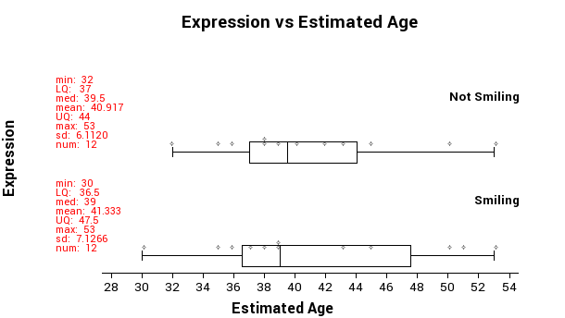 | Graph displayed with summary statistics
Analysis
The age estimates of the photo of Robert Downey Jr. smiling were much more spread out than the photo of him with a straight face as shown by the width of the box and whisker plot. The smiling group’s median was 0.5 years smaller than the not smiling group, and the means only had a difference of 0.416 years. The data from the groups look like what I would expect to see if chance was acting alone in the experiment. | Key features of the displays and statistics are described
I need to find out if a difference between the medians of 0.5 years is likely to just be from chance alone, or if this could be due to smile in the photo. I used the randomisation test on the medians and the results are shown below. | Statement of what test is going to be carried out
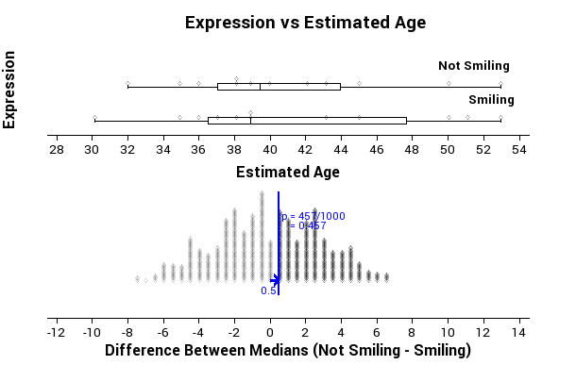 | Results of the test are displayed
A difference of 0.5 or more comes up 457 times of the 1000. | Summary given
As 45.7% of estimates produced by random allocation are at least as far from zero as the observed estimate, then the data provides no evidence of a link between the two variables. This means that because the probability is high, it would be highly possible a difference of 0.5 years could happen by chance alone. | Inference stated
Conclusion
Overall I see that there is not sufficient evidence to support the claim that people who are asked to estimate the age of a person who is smiling will give a different estimate than those who are asked to estimate the age of the same person who is not smiling. | Conclusion given
Appendix: Data
Estimates of ages:  Straight Face: 36, 43, 35, 32, 38, 53, 45, 42, 40, 39, 38, 50  Smiling: 53, 39, 38, 36, 37, 43, 30, 39, 50, 35, 45, 51 | Raw data given as appendix.

Assessment Guidelines – 91583 – Conducting an Experiment
Below is the coversheet that will be used to mark your internal.

 | Achieved (all compulsory) | Merit… Achieved PLUS | Excellence… Merit PLUS
Problem | What is going to be investigated is clearly stated.  A causal relationship question is posed that can be investigated by conducting an experiment. | A prediction is made for the experiment with justification using research findings. (Compulsory) | Contextual and statistical knowledge is informed by research to develop the investigative question. (Compulsory)
Plan | The following are identified.  - The type of experiment.  - The experimental units.  - Treatment variable and how it will be manipulated.  - Response variable and how it will be measured.  - How treatments will be allocated to the experimental units.  - Other sources of variation that could affect the results of the experiment. | The allocation of the treatment to the experimental units is justified.  Explanation given as to how other sources of variation could affect the findings. | How the treatment variable (including levels and groups) and response variable were defined for the experiment is justified.  Contextual knowledge is used to identify relevant variables that could affect the response variable.  Statistical knowledge is used to describe how these sources of variation could be controlled or balanced.
Experiment | Data from the experiment is collected and recorded.  Any issues that occurred during the experiment were recorded. | Discussion is given about how issues might affect the findings. | A reflection is given on how the experiment was conducted.  Explanations given as to how issues might be addressed.
Data | Appropriate displays and summary statistics are produced.  This includes dot plots, box and whisker, summary statistics and randomisation distribution. | Displays must have a good title and axis labelled correctly with units.
Analysis | Key features of the displays and statistics are described.  An appropriate statistical method is selected to answer the investigative question.  The selected statistical method is used to make a correct inference about the causal relationship investigated. | The choice of statistical method in relation to causal relationship is justified.  The strength of the evidence for the causal relationship is interpreted. | A feature of the data is used to explore further factors and effects.  Statistical insight is used to justify the method in relation to the causal relationship.
Conclusion | Each component of the investigative process is clearly communicated. | The design of the experiment is linked to the results and research findings. (Compulsory) | A discussion is given how findings relate to research findings. (Compulsory)  Contextual knowledge is used to generalise to the wider experimental situation in their discussion of their findings.
Appendix | Data and any other resources included as an appendix.

Final grades will be decided using professional judgement based on a holistic examination of the evidence provided against the criteria in the Achievement Standard.

